**LABORATORY EXERCISE 2**

**SETTING UP THE DEVELOPMENT ENVIRONMENT**

# Learning Objectives

* To understand the process of setting up a development environment for software projects.
* Install and configure necessary tools, including IDEs, databases, and frameworks.
* Learn the basics of version control using GitHub or GitLab.
* Set up a structured project workspace for development.
* Enhance teamwork and collaboration in environment setup.

# Prerequisite student experiences and knowledge

Students should have basic knowledge of software development tools, programming languages, and database management. Familiarity with the command line and file system navigation is helpful. Prior exposure to version control concepts, though not mandatory, will be beneficial for understanding repository setup.

# Background

A well-configured development environment is crucial for efficient and error-free software development. Proper installation and setup of IDEs, databases, and frameworks enable developers to work seamlessly. Version control systems like Git help manage code changes collaboratively, ensuring an organized workflow. Developers can maintain code consistency and improve team efficiency by establishing a structured project workspace.

# Materials/Resources

* PC/Internet
* Pen & Notebook
* Development Tools (e.g., Visual Studio Code, IntelliJ IDEA, Eclipse)
* Database Software (e.g., MySQL, PostgreSQL, MongoDB)
* Version Control System (e.g., Git, GitHub, GitLab)
* Frameworks/Programming Languages (e.g., Node.js, Django, Spring Boot)

# Laboratory Activity

In this exercise, students will work in groups to set up a development environment. The activity consists of the following tasks:

1. **Install Necessary Tools**

* As a team, decide on the appropriate IDEs and development tools based on the project requirements.
* Download and install necessary databases (e.g., MySQL, PostgreSQL).
* Set up frameworks and programming environments (e.g., Node.js, Python, Java).
* Install API testing tools (e.g., Postman, Swagger).

1. **Create a Version Control Repository**

* Register a team repository on a platform like GitHub or GitLab.
* Clone the repository to local machines and initialize it for project use.
* Each team member should create and push an initial commit.

1. **Configure a Basic Project Structure**

* Define a folder structure for source code, documentation, and resources.
* Set up environment variables and configuration files.
* Establish a README file with project details and setup instructions.

1. **Collaborate and Document**

* Assign team members to different setup tasks.
* Document the installation steps and configurations.
* Prepare a brief demonstration of the setup process.

**Expected Output/Results**

* Successfully installed and configured development tools.
* A functional version control repository with an initial commit.
* A structured project workspace with organized files.
* Group presentation of the setup process.

**Question**

1. Explain the importance of developing a development environment before starting a project.

-The importance of developing a development environment is to have consistency. It ensures that all tools, software, and settings are properly set up, making work easier and more organized. This is especially helpful in teams, where using the same setup prevents errors and compatibility issues.

1. Discuss the benefits of version control in a team-based software project.

- First, one big benefit is keeping track of changes. Version control systems like Git save a record of all updates, so developers can see who made changes and go back to an earlier version if needed. This helps avoid losing important work by mistake.

-Another advantage is team collaboration. Multiple developers can work on different parts of the project at the same time without overwriting each other's work. Using branches, they can test new features separately before merging them into the main project.

-Lastly, it ensures project security and backup. If something goes wrong, the team can restore an earlier version of the project, preventing major setbacks

1. Provide a flowchart diagram illustrating the development workflow in your project.

**Output / Results**

Our ERD

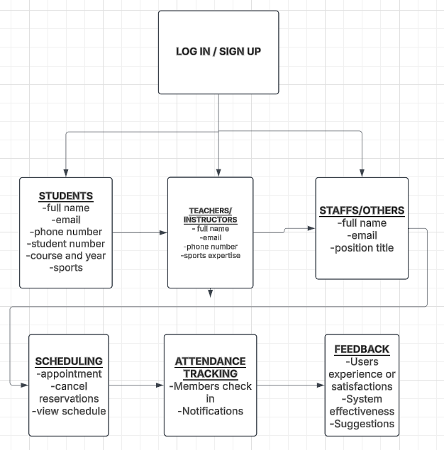

OUR NEW DESIGN

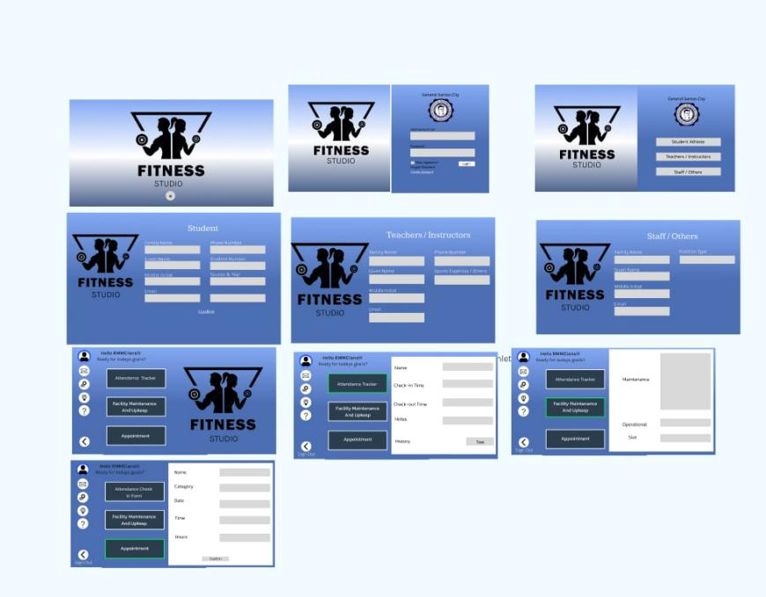

THE PLAN

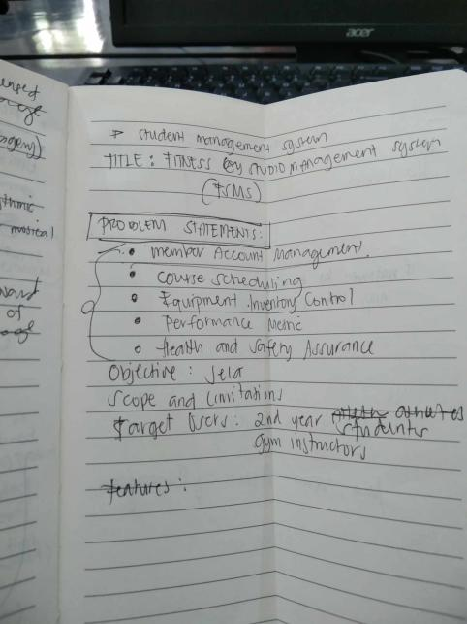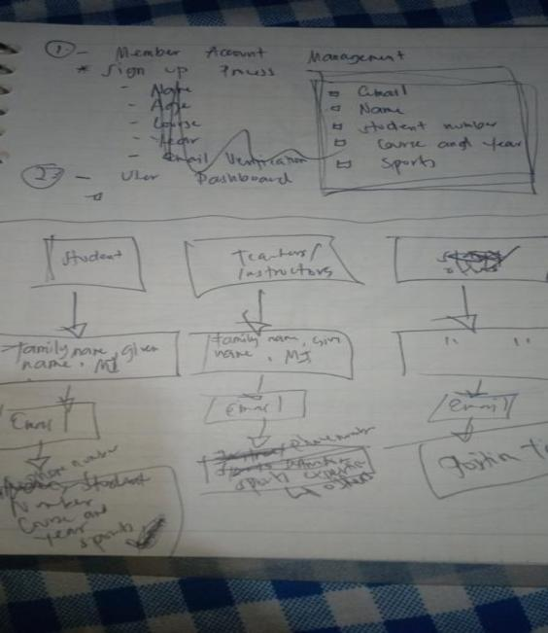

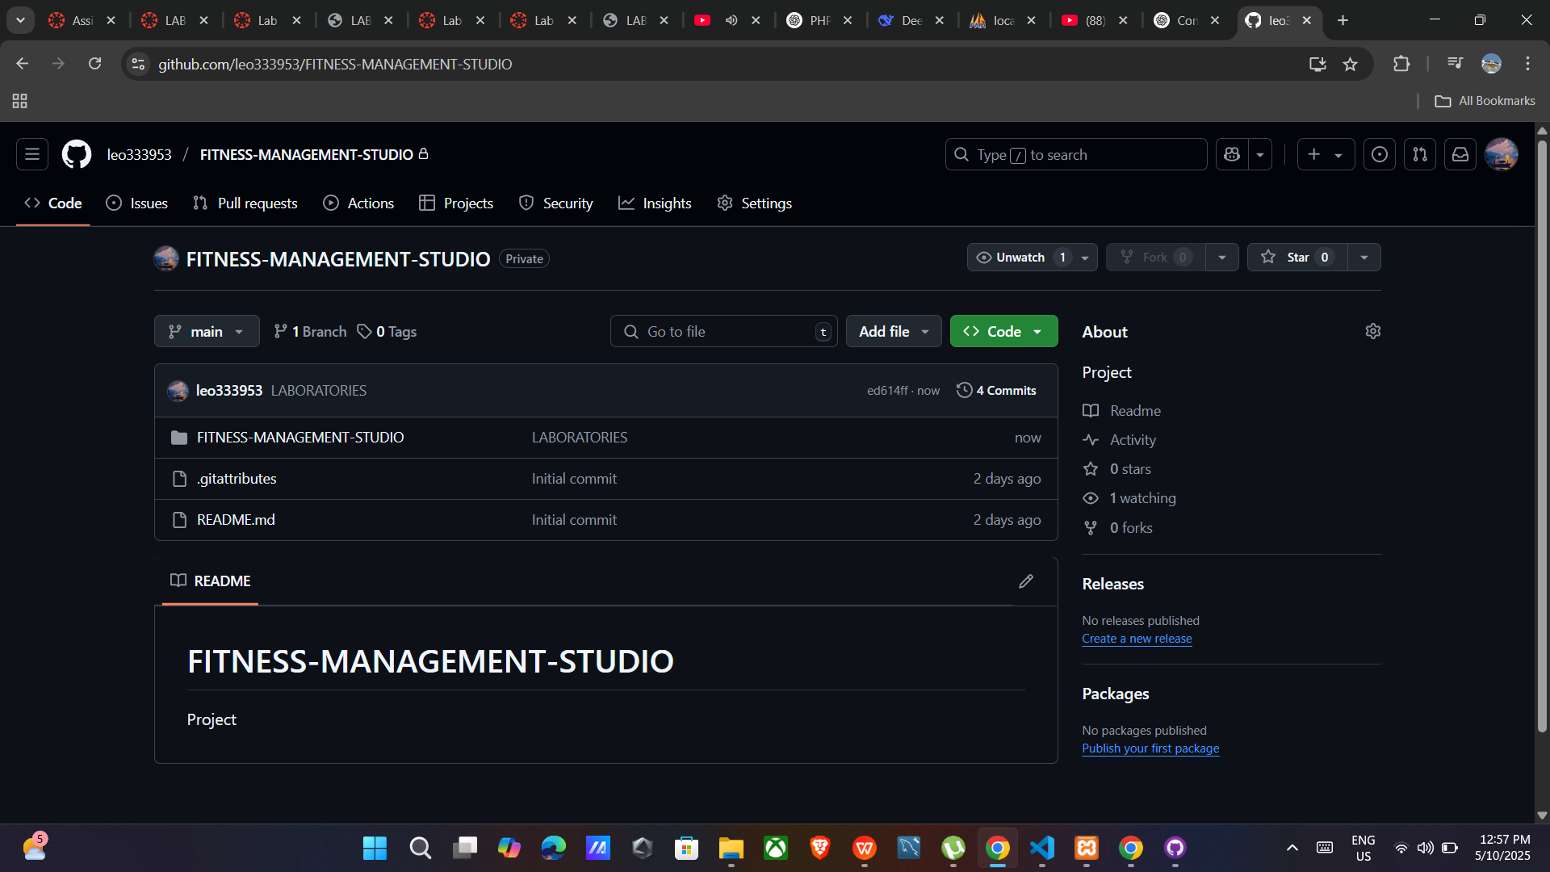

**Conclusion**

Setting up a development environment helps make software development easier and more organized. Installing the right tools, databases, and frameworks reduces errors and improves workflow. Using version control like Git helps teams track changes and work together smoothly. A well-structured project setup also keeps everything in order. This activity shows that having a proper setup is important for a successful project.